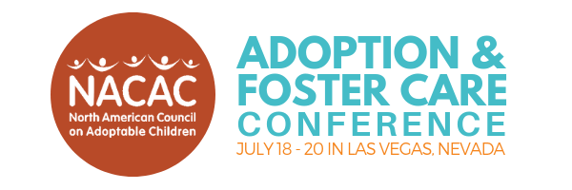

Date

Dear <supervisor’s name>,

With this letter, I request to attend NACAC’s 45th annual adoption and foster care conference in Las Vegas, Nevada on July 18–20, 2019 (pre-conference session July 17). As the leading adoption and foster care conference in North America, this conference will give me new skills I need to do my best as a <position title> and enhance <organization name>’s initiatives moving forward.

The three-day conference gathers about 800 individuals touched by adoption and foster care and features more than 80 workshops on a number of topics addressing mental health, child welfare, foster care, adoption services, and youth and family involvement. By attending this conference, I can learn new techniques, network with peers, and learn more about issues in the field of child welfare—improving our organization and helping me better meet the needs of the children and families we serve. Specifically, I hope to gain the following tools from the sessions listed below:
- Workshop Name 1: Brief description of how it might help you achieve goal.
- Workshop Name 2: Brief description of how it might help you achieve goal.
- Workshop Name 3: Brief description of how it might help you achieve goal.
- Workshop Name 4: Brief description of how it might help you achieve goal.

I am confident that NACAC’s workshops and the discussions they will spur will enhance my work at <name of organization>, which is why I’m seeking support to cover the conference expenses. The total price of my attending NACAC’s conference is $XX. The breakdown of costs is as follows:
- Pre-conference registration (optional): $125
- Registration fee: $380
- Travel (airfare/train ticket + ground transportation): $XX
- Hotel/Planet Hollywood Resort and Casino: $119 plus a resort fee of $37 per night and tax
- Meals: $XX

I hope you can see how valuable my attendance at this conference would be for <organization>. I know that with the tools and experiences gained at NACAC’s adoption and foster care conference, I can return to work reinvigorated and ready to share new techniques with my colleagues.

For more information on NACAC’s conference, visit nacac.org/get-training/conference or email conference@nacac.org. I so look forward to hearing from you and how this training can improve our work in this field!

Sincerely,
<Name here>

Or, our organization can receive a registration discount and membership benefits like a subscription to NACAC’s quarterly newsletter, Adoptalk, by becoming a member!
Please note that as the hotel fills, the rate on some nights could increase to $149 plus the resort fee and tax.

